**Auto-Incident-Assignment application**

Description-

This application is designed to assigned the incidents automatically to a particular owner on the basis of application name. It is scheduled in the task scheduler of the remote desktop(yh1008211dt) to be repeated in every 10 mins so that whenever a new incident is raised in the Solution Management site of MAB, it should be assigned immediately.

Important points to be followed-

* Whenever there is any change in the code, new jar file has to be generated and kept at this location - C:\Selenium\automation
* Whenever there is any change in the Atos Staff listing excel sheet, updated excel sheet has to be kept at this location - C:\Selenium\ExcelSheet. Previous one should be renamed as Excel File_Backup.
* Version of the chromedriver should be 99, if in case its not the said version so it has to be updated and replaced the previous one at this location - C:\Selenium\chromedriver
* Just check once in the datafile.properties at this location - C:\Selenium\ConfigurationFile\, name of the excel sheet should be same as the updated one.

Steps for deployment-

Firstly the jar file of this application has to be scheduled in the task scheduler. It has been scheduled already so it gets repeated in every 10 mins.

If any changes has to be made regarding its scheduling-

* Open the task scheduler, click on the task scheduler library in the upper left corner. The AutoIncident task will be visible as it is running.

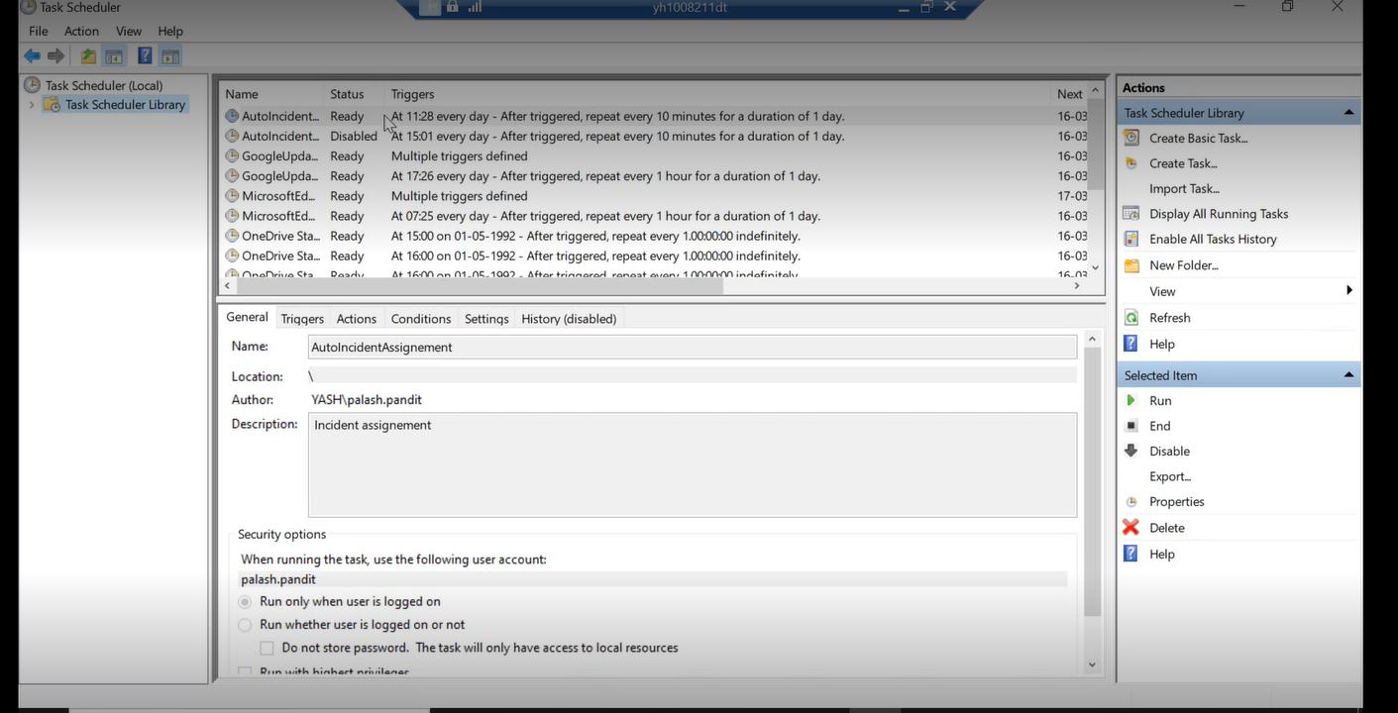

* As for the first time it was scheduled at 11.28 so that time has been recorded then since its been repeatedly getting triggered in every 10 mins. The difference of 10 mins can be seen in Next Run Time and Last Run Time columns.

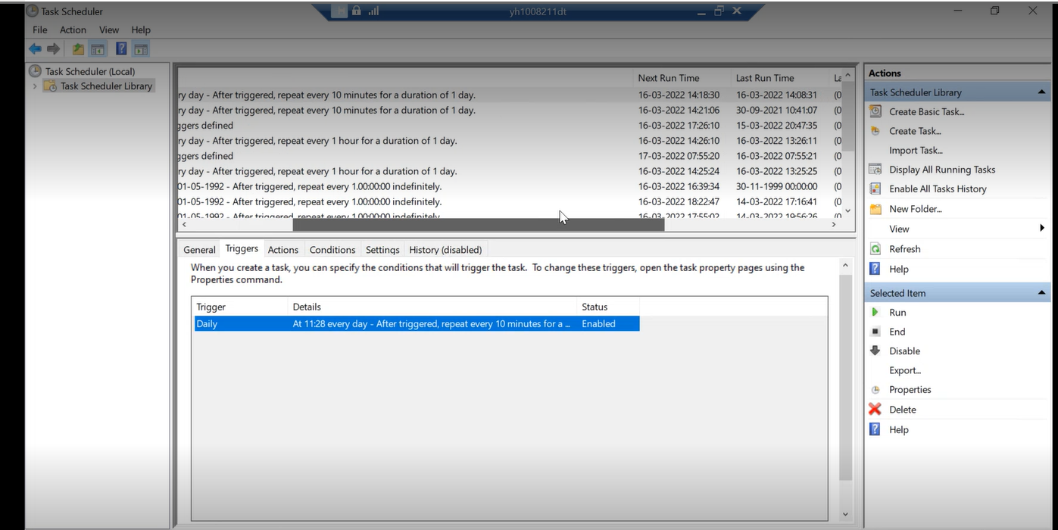

* Right click on this task then select Properties so any changes according to any new information can be done here.

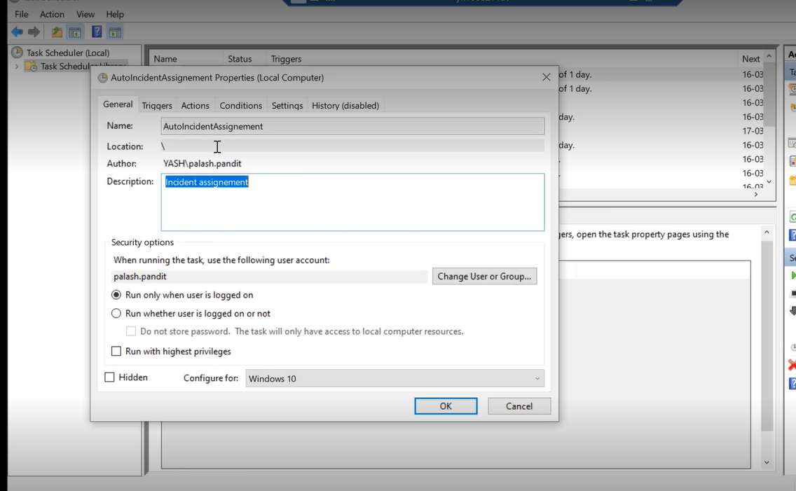

* The location of the jar file is mentioned in the Actions of the task.

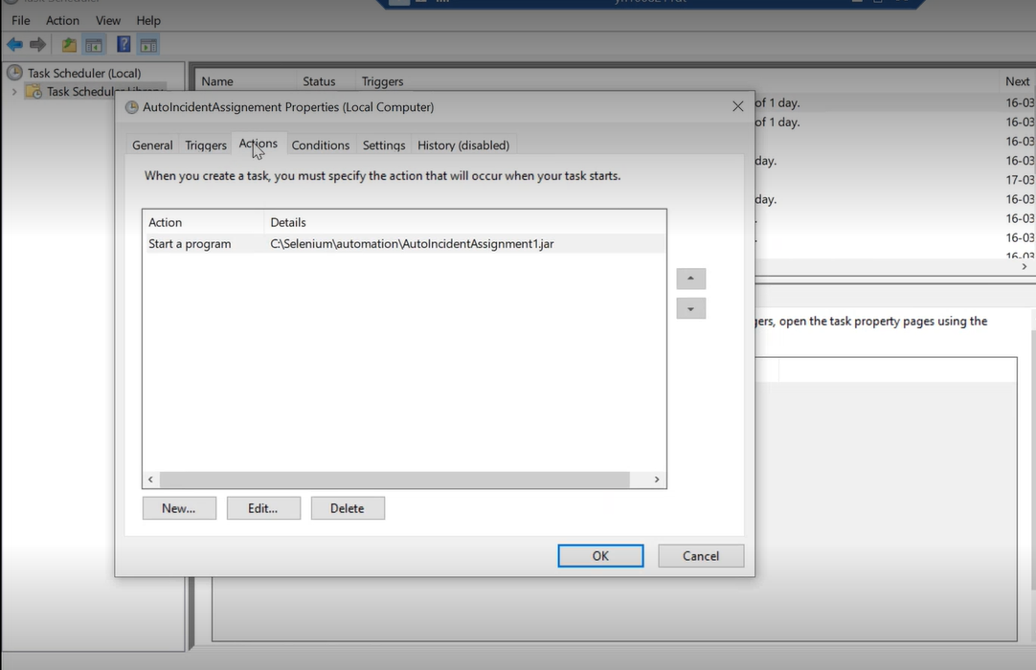

Logs get generated and they are kept in the date wise folder at this location - C:\Selenium\LoggingFiles

Reasons for break-down of the application-

* System might get stopped in between
* Task scheduler might get stopped or faced any issue
* Application and Owner name are not found in excel sheet
* Chromedriver version is not appropriate

Autoassignment application will get stopped and team won’t be notified regarding the same to look into the issue

So to resolve this issue, a mail should be sent in every 6 hours stating that application is working fine and if any mail is not received then the team will get that something is wrong with the application as mail is not generated…

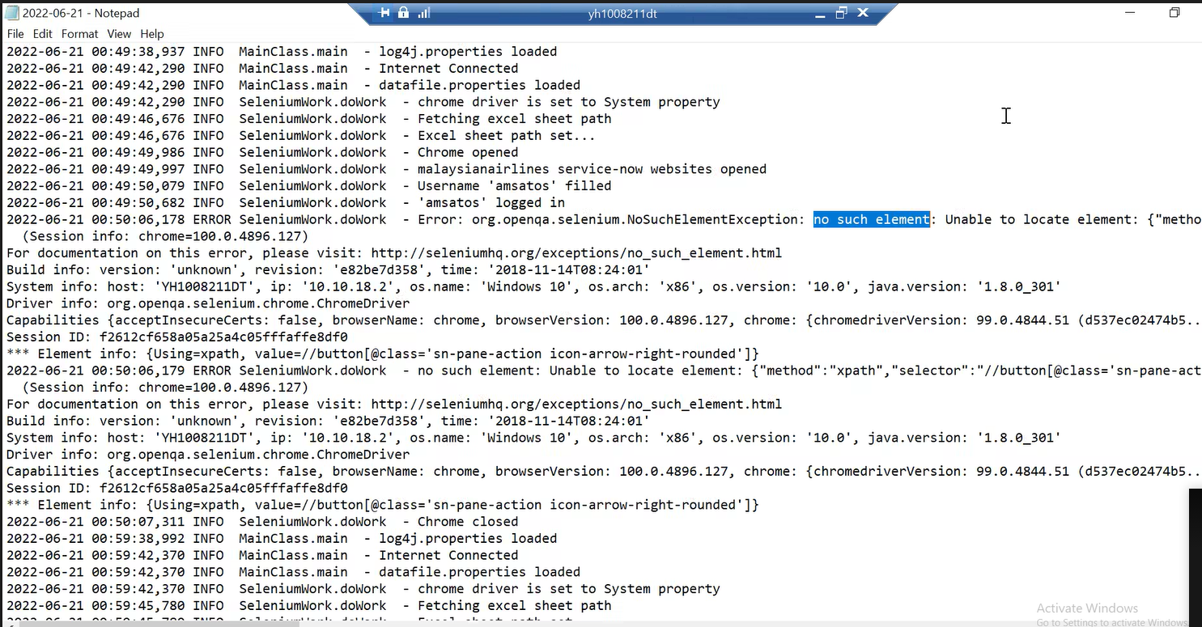

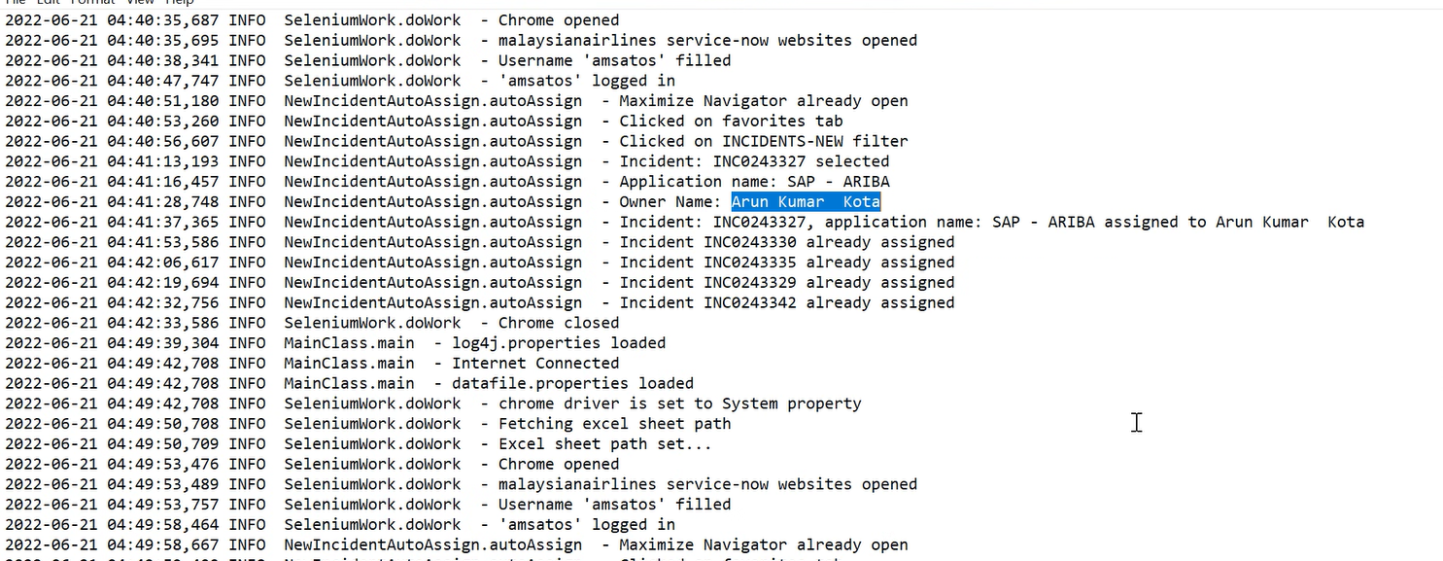

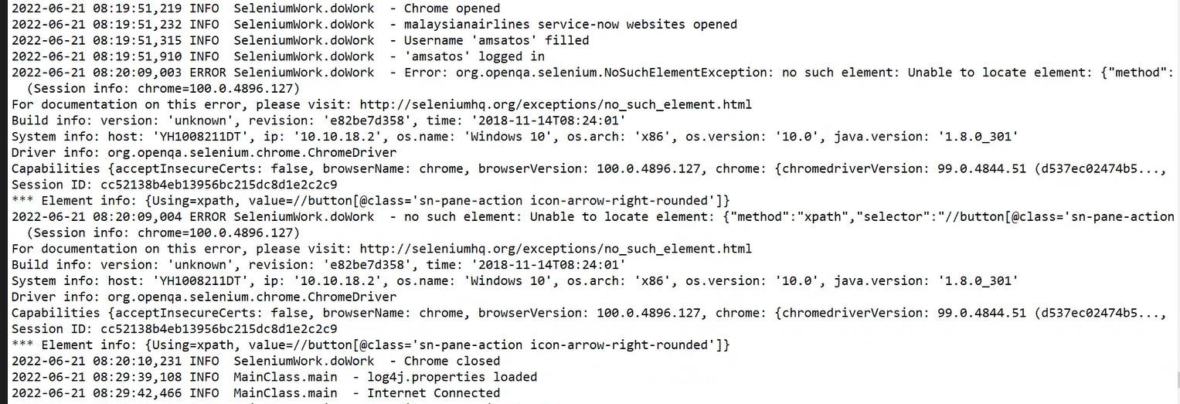

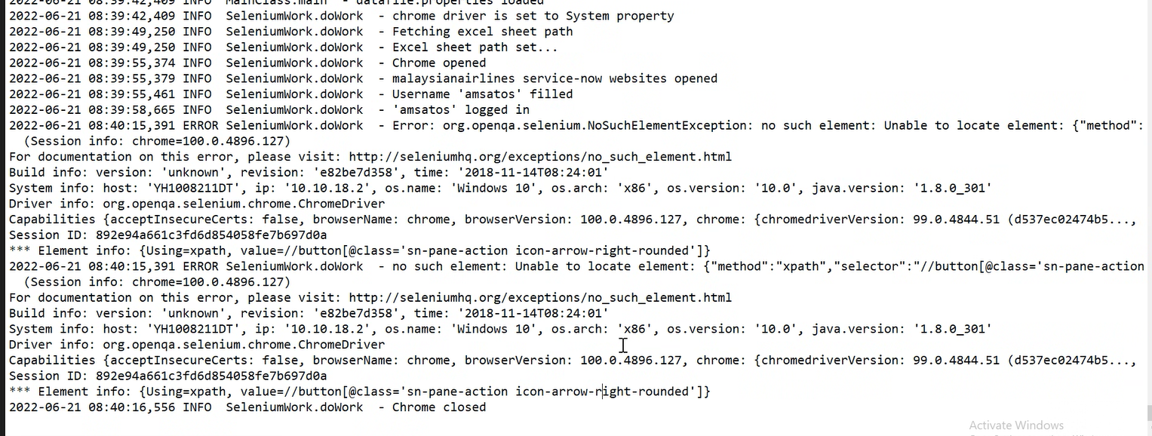

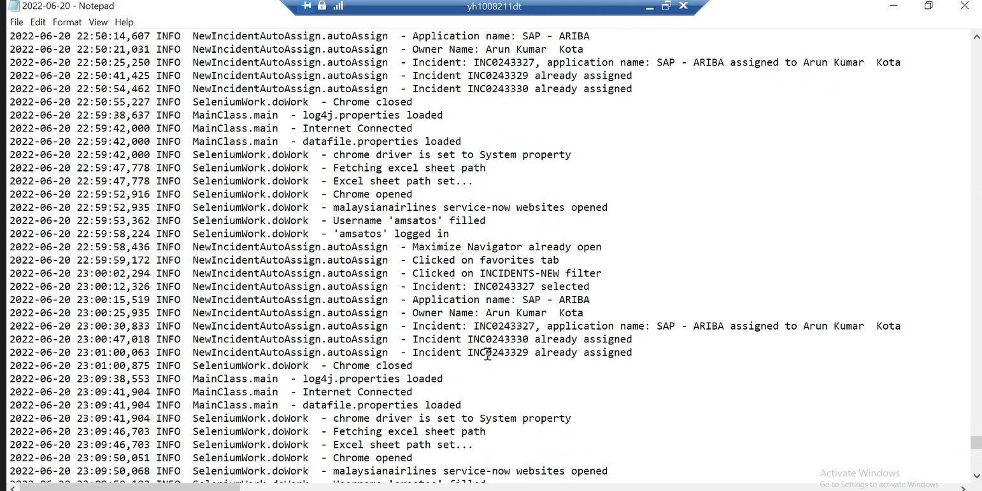

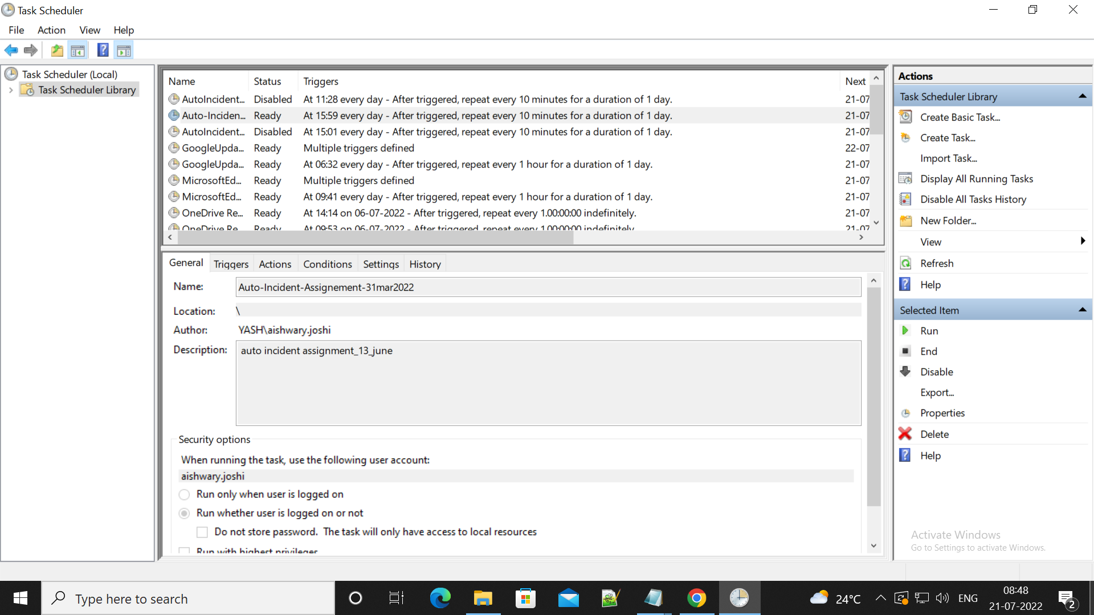

2022-07-20 00:30:45,833 ERROR SeleniumWork.doWork - unknown error: DevToolsActivePort file doesn't exist

Build info: version: 'unknown', revision: 'e82be7d358', time: '2018-11-14T08:24:01'

2022-07-20 03:01:07,975 ERROR SeleniumWork.doWork - Error: org.openqa.selenium.WebDriverException: chrome not reachable

Build info: version: 'unknown', revision: 'e82be7d358', time: '2018-11-14T08:24:01'

System info: host: 'YH1008211DT', ip: '10.10.18.2', os.name: 'Windows 10', os.arch: 'x86', os.version: '10.0', java.version: '1.8.0_301'

Driver info: driver.version: ChromeDriver

2022-07-21 01:40:08,584 ERROR SeleniumWork.doWork - Error: org.openqa.selenium.NoSuchElementException: no such element: Unable to locate element: {"method":"xpath","selector":"//button[@class='sn-pane-action icon-arrow-right-rounded']"}

(Session info: chrome=100.0.4896.127)

2022-07-21 05:40:15,221 ERROR SeleniumWork.doWork - Error: org.openqa.selenium.NoSuchElementException: no such element: Unable to locate element: {"method":"xpath","selector":"//button[@class='sn-pane-action icon-arrow-right-rounded']"}

(Session info: chrome=100.0.4896.127)

INC0245923, application name: APP - SCV assigned to Sujit Patil

2022-07-21 08:35:46,250 ERROR SeleniumWork.doWork - Error: org.openqa.selenium.TimeoutException: timeout: Timed out receiving message from renderer: 300.000

(Session info: chrome=100.0.4896.127)